# False Positive Documentation

Kindly provide the answers for the following queries regarding the vulnerability.

1. Name of the Application

|  |
| --- |
| SetupAI |

1. Package ID/Version ID/Listing ID

|  |
| --- |
| 04tDp000000uQd2IAE |

1. Partner Name

|  |
| --- |
| SetupAI |

1. Document Filing Date (YYYY-MM-DD)

|  |
| --- |
| 2023-12-19 |

1. Target URL (Optional)

|  |
| --- |
|  |

1. Review Date (In Case if app already undergone security review)

|  |
| --- |
|  |

#### Repeat Step 6 to 9 in case of multiple Vulnerability

1. Vulnerability Name

|  |
| --- |
| Validate CRUD permission before SOQL/DML operation or enforce user mode |

#### *Meant for the Internal Salesforce Security Team*

|  |  |
| --- | --- |
| Final Comment from Salesforce Team |  |
| Date of Review (YYYY-MM-DD) |  |
| Result |  |

1. Detected By

|  |
| --- |
| * Chimera * PMD * Security Review * Others,   If case of others Please provide details : Code Analyzer |

1. Detailed explanation for considering False Positive ( Elaborate as much as possible)

|  |
| --- |
| I have a custom CRUD class that contains methods for checking user CRUD access to the Chat__c and Message__c objects so that all field and object access can be checked more efficiently.  The Code Analyzer picked up a violation on line 25 of Controller.cls where a new Message__c is inserted. This insert statement is inside an if statement on line 21 that checks CRUD access on both Chat and Message.  2 more violations are on lines 42 and 43 of Controller.cls inserting a Chat__c and a Message__c. These are inside an if statement on line 40 checking CRUD access.  Line 52 of Function.cls creates a Message__c record. This is inside a CRUD check if statement on line 51.  Lastly, on line 43 of the CalloutSecurity class, there is an update on a SetupAI__Token_Usage__c record. This is a custom setting so this is a false positive. |

1. Evidence (screenshots of the code, implementation, Command Output)

**Controller.cls - lines 16-52**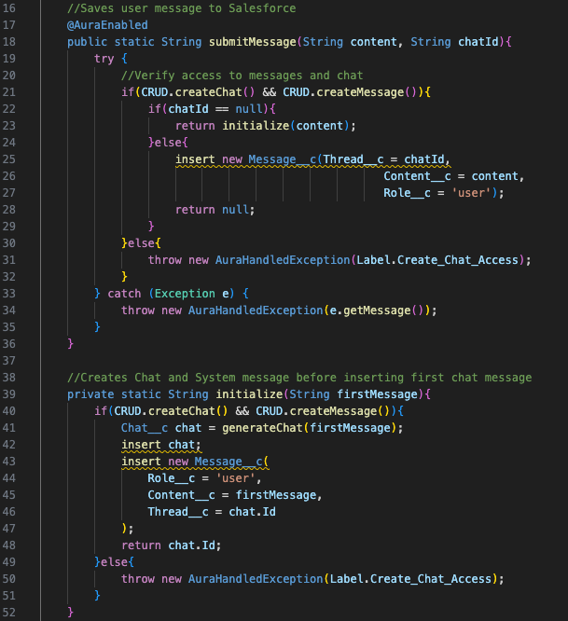

**Function.cls - lines 50-56**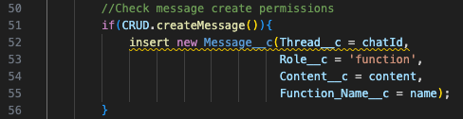

**CRUD.cls - entire class**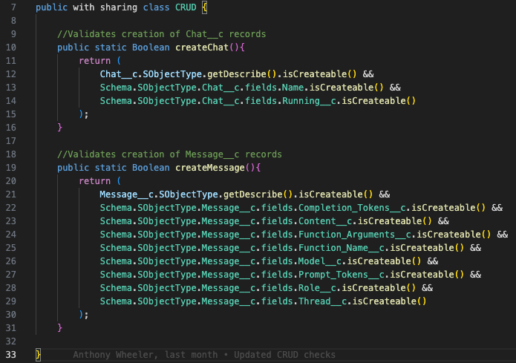

**CalloutSecurity.cls**